✴

## Document an existing experience

##### Narrow your focus to a specific scenario or process within an e**E**xi**n**st**t**in**ic**g**e**product or service. In the **Steps** row, document the step-by-step procesHsowsodmoeesosnomeeone typically experiences, then add detail to each of the other rowsin.itially become aware

of this process?

## Enter

What do people experience as they begin the process?

## Engage

In the core moments in the process, what happens?

**TIP Exit**

As you add steps to the

What do people

experience, move each these “Five Est”ytpheiclaelfltyorerxigphetrience

dependiansg tohnethperoscceensasriofinishes? you are documenting.

**customer will learn the applications and how to use them**

By using the application soil monitoring and irrigation methods can be done effectively than the

existing methods

wastage of water will be lesser as compared to other irrigation system

productivity yield will be higher

**In online mode we will do digital marketing using advertisment**

we will reach the customer directly ask about there problems and provide effective solutions if their problems match our application

## Extend

What happens after the experience is over?

Customer experience journey map

**Steps**

What **S**d**C**o**E**e**NA**s**R**t**I**h**O**e person (or

they will develop some sort of trust towards the application and will be eager to learn more about the application

The customer will get to handle application through the person who has the knowledge about that application

group)

typically experience?

**Browsing, booking,**

**attending, and rating a local city tour**

Compared to

# the present

system this

# application is more effective

### Use this framework to better understand customer needs, motivations, and obstacles by illustrating a key scenario or process from start to finish.

we will provide them knowledge about our application and make farming even more easier

When possible, use this map to document and summarize interviews and observations with real people rather than relying on your hunches or assumptions.

Created in partnership with

The primary goal is to lower the productivity loss and to make farming easier

#### Interactions

What interactions do they have at each step along the way?

**People:** Who do they see or talk to?

**Places:** Where are they?

**Things:** What digital touchpoints or physical objects would they use?

#### Goals & motivations

At each step, what is a person’s primary goal or motivation? (“Help me...” or “Help me avoid...”)

At the starting the

###### customer will be

worried about the

###### process and they

will think whether

it will be effective

# They will be

There will no soil erosion

able to use

They will have good experience while using this app and they will have productive yields

# the app with

our technical

# assistance

#### Positive moments

They will be satisfied with the outcome & will not their decision of using this application

They will expand their usage to other farming application

They will compare the growth and production before and after the use of application

Initially the growth of the plants can be seen & it provides more hope to use the application

What steps does a typical person find enjoyable, productive, fun, motivating, delightful, or exciting?

They will get to

###### know about the

They may recomend their positive feedbacks about the app and help people to work with the app

positively they will learn the app technolgy

tremondous

developments

in agriculture

#### Negative moments

they will be aware of many new techniques in farming

At first there will be excited to see on how the technology works

What steps does a typical person find frustrating, confusing, angering, costly, or time-consuming?

At first they

will find the

If learning become an challenging task one cant handle the app all alone and should have a people assiting them always

There will be hard learning process and understanding

The learning process is not easy for everyone the understanding capacity differs

And once if they trust and have enough budget they will buy the app and the learning process is quite challenging

### app costly

and will have

### trust issues

[**Share template feedback**](https://muralco.typeform.com/to/CiqaHVat?typeform-source=app.mural.co)

#### Areas of opportunity

This application can be used in terrace gardening

Customers will come to know about the tremendous growth in agriculture

How might we make each step better? What ideas do we have? What have others suggested?

**Need some inspiration?**

See a finished version of this template to kickstart your work.

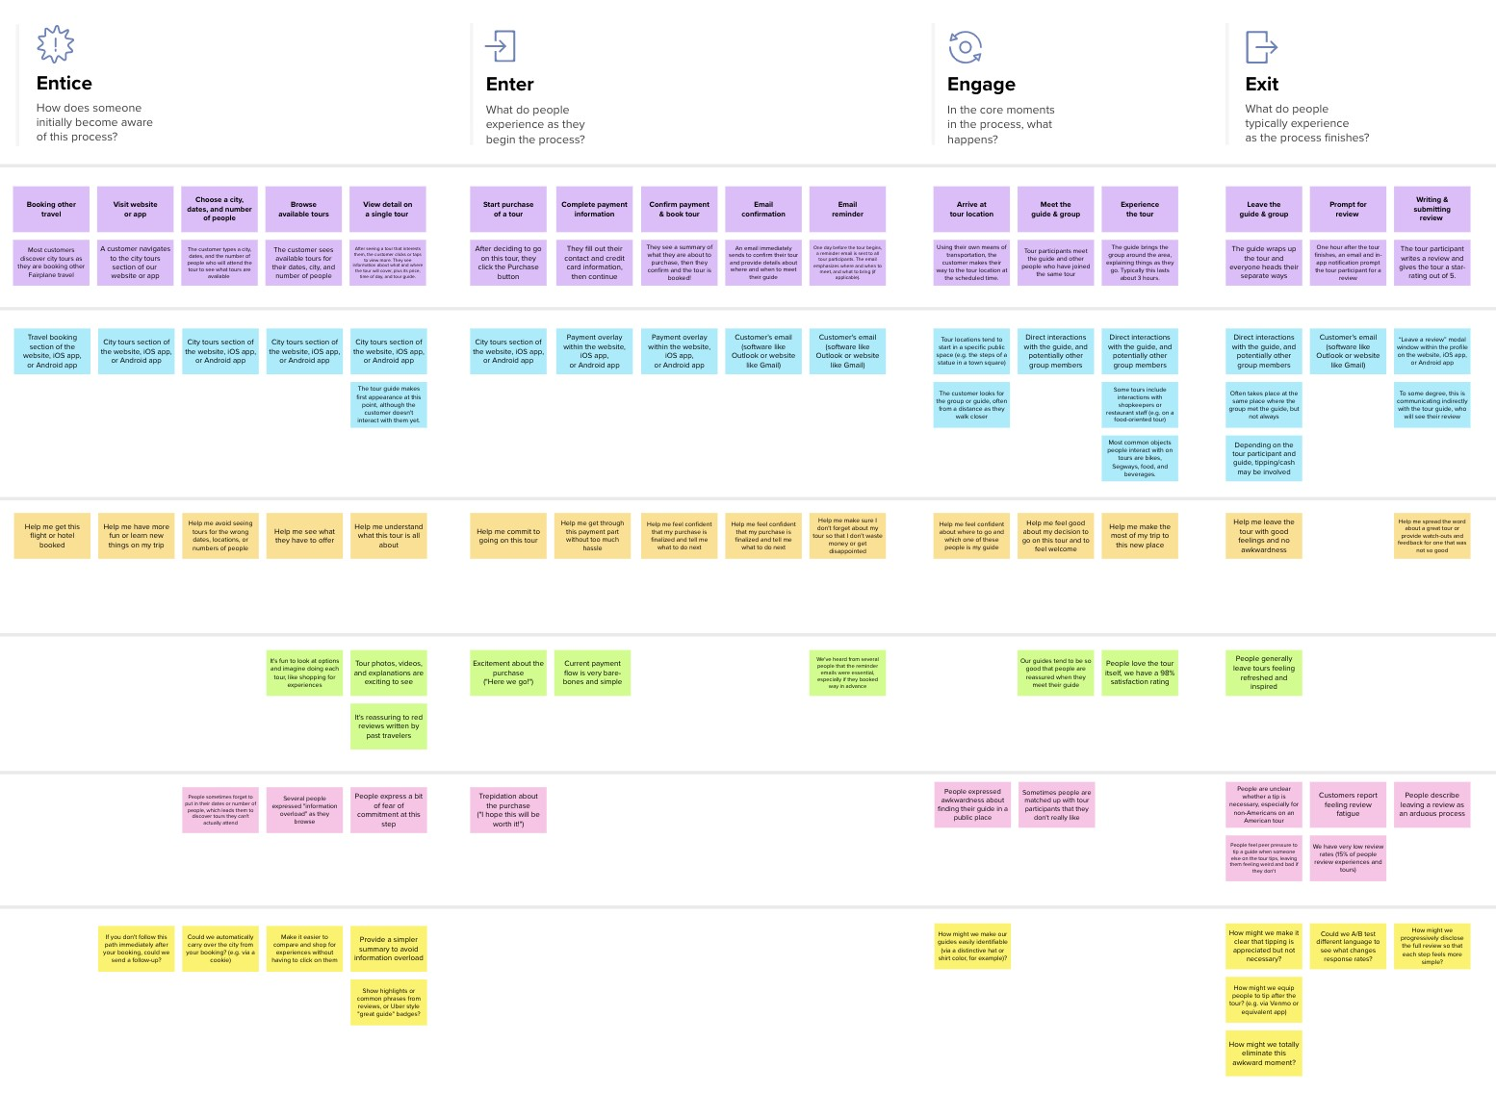

**Template**

[**Open example**](https://app.mural.co/template/f59f644b-b4b4-47b5-9ed6-3a8c71ceb612/896b31fe-5597-40ef-9b06-3811a1a45ace)